# **Things to do in Windows 10**

1. Powertoys - <https://github.com/microsoft/PowerToys/releases>
2. QuickLook - <https://github.com/QL-Win/QuickLook/releases>
3. wsl & vscode
4. clipboard - win+v
5. multi-virtual windows – ctrl+win+d, ctrl+win+left/right
6. snip n sketch – win+shift+s
7. windows sandbox [only in windows 10 pro] – useful for opening files like those shown in <https://youtu.be/Z00Qym4WATM>
8. Use 7zip, an open source alternative for winrar, and definitely 100000x better  
   <https://www.7-zip.org/>   
   setting defaults for this app: run 7zip as admin > tools > options > click on the plus sign on the right side [1], [out of the two, that is]
9. Quick Assist – inbuilt alternate to TeamViewer
10. Fdm [use version 5, as 6 has scaling issues]- alternate to utorrent without ads, and better features <https://dn3.freedownloadmanager.org/5/5.1-latest/fdm5_x64_setup.exe>   
    <https://www.freedownloadmanager.org/download.htm>
11. File Converter - <https://github.com/Tichau/FileConverter/releases>

# **Things to check out**

1. if you have a clg email, get 1tb of onedrive storage @ <https://www.microsoft.com/en-us/education/products/office>
2. fluid docs - Open Source from MS!
   1. <https://www.theverge.com/2020/5/19/21260005/microsoft-office-fluid-web-document-features-build>
   2. <https://support.microsoft.com/en-us/office/get-started-with-fluid-preview-d05278db-b82b-4d1f-8523-cf0c9c2fb2df?ui=en-us&rs=en-us&ad=us>
   3. <https://fluidpreview.com>
3. Samsung-Windows Exclusives [3] Cause, why not for some extra productivity! ¯\_(ツ)_/¯
   1. opening your android apps in Windows as individual windows! [Link to Windows]
   2. And sync your clipboard cross platform! [Using Samsung Flow]

[Why only with Samsung devices, **‘cause they developed it!** Get a Samsung A series next time!]

1. microsoft powerbi - business intelligence?
2. MS DOS is now open source! Check out the most famous os of the 90’s!
   1. <https://devblogs.microsoft.com/commandline/re-open-sourcing-ms-dos-1-25-and-2-0/>
   2. <https://github.com/Microsoft/MS-DOS>
3. 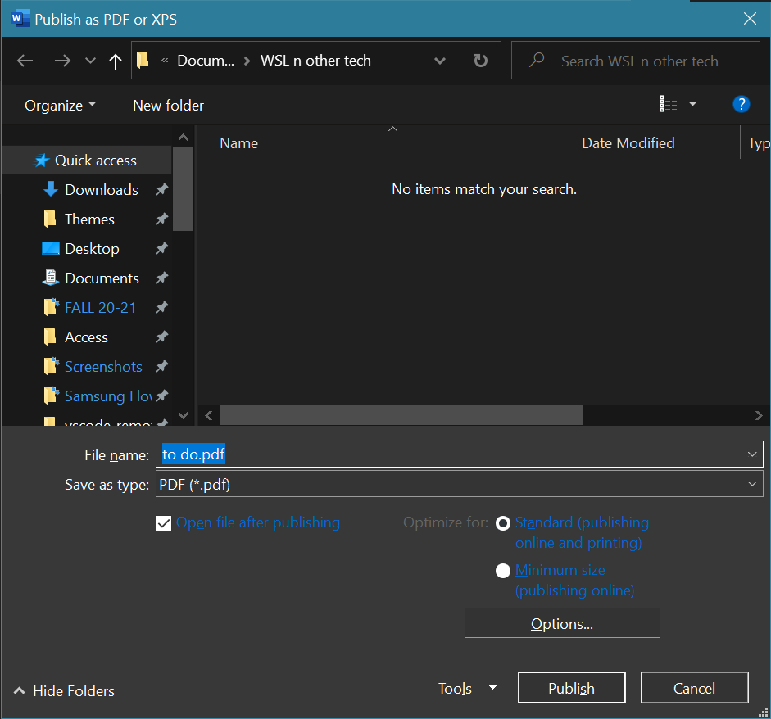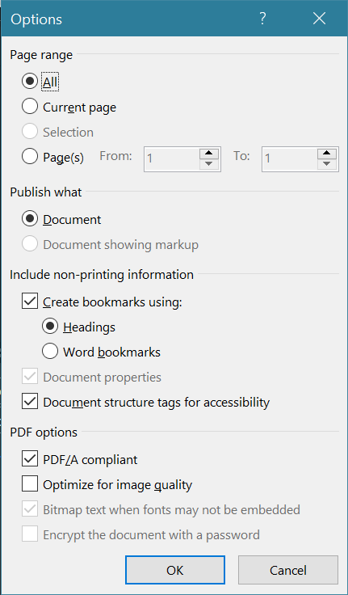Bookmark your word document when converting to pdf



1. OneDrive’s differential sync [2]….  
   <https://www.windowscentral.com/onedrive-rolls-out-differential-sync-save-you-time-and-data-when-syncing-files>

1. 7zip defaults  
   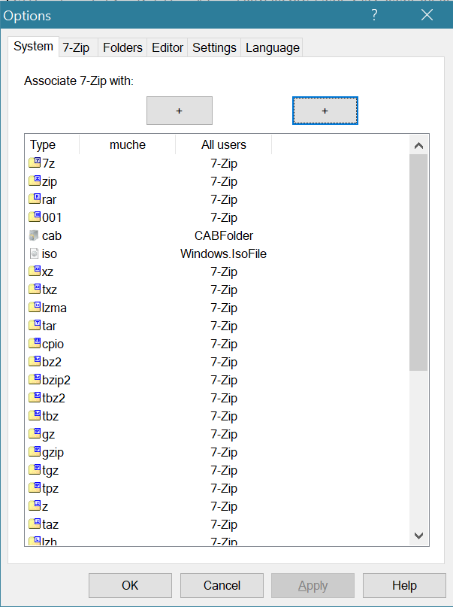



1. OneDrive Diff Sync  
   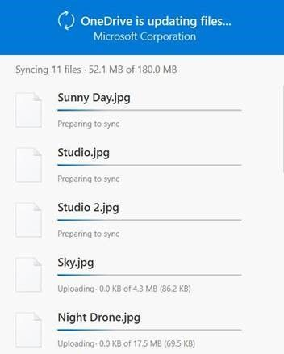  
   The OneDrive sync client will only synchronize the changes that you make to your files. Note the number in parenthesis represents the actual amount of the file that is being synced - not the whole file.  
     
   <https://techcommunity.microsoft.com/t5/microsoft-onedrive-blog/onedrive-announcements-sharepoint-conference-2019/ba-p/616047>
2. Samsung - Windows Exclusives

